https://www.hackerearth.com/problem/algorithm/digit-sum-4/

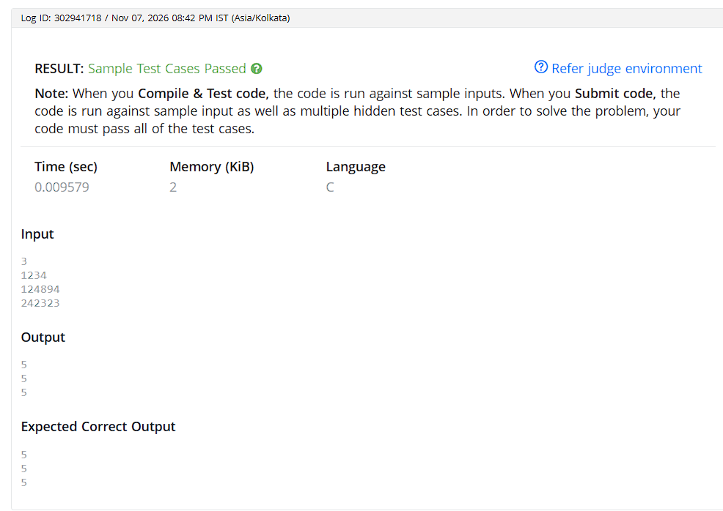
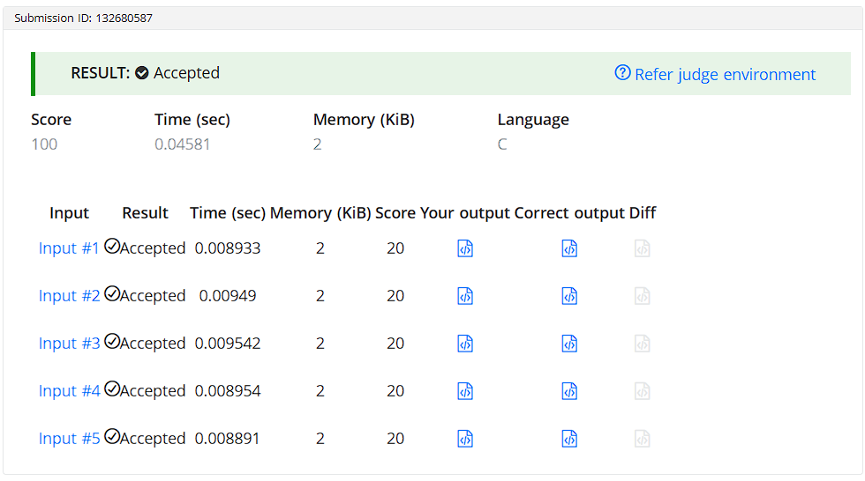

CODE:

#include <stdio.h>

int main() {
int T;
scanf("%d", &T);

while (T--) {
int N;
scanf("%d", &N);

int last = N % 10;
int first = N;
while (first >= 10) {
first /= 10;
}

printf("%d\n", first + last);
}

return 0;
}

